|  |  |  |
| --- | --- | --- |
| |  | | --- | | **D:\CE\WhatsApp Image 2021-05-08 at 4.35.03 PM.jpeg**    ***“CULTIVATING EXCELLENCE IN EVERY STUDENT”***  **‘**  **RAKESH KUMAR**  **M.Sc. (Chemistry) B.Ed.**  **CTET, PSTET, HPTET qualified**  **chemistryexpert21@gmail.com** | | **Chapter-1 Lecture - 1**  **Chemical reactions and equations**  *“Chemistry is the science of molecules and their transformations. It is the science not so much of the one hundred elements but of the infinite variety of molecules that may be built from them”.* | |

**General Introduction:**

## What Is Science?

**Science** is the study of the physical and natural world through observations and experiments. Science is all around us. Right now, the fact that you exist and are in the process of reading this lesson is science. The process of creating the air we breathe - also science. The food we enjoy, water we drink, and clothes we wear are all based in science. Looking up into the atmosphere gives us a glimpse into astronomy, another branch of science.

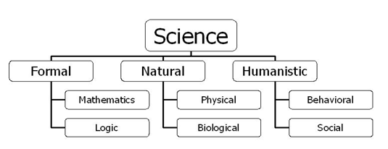

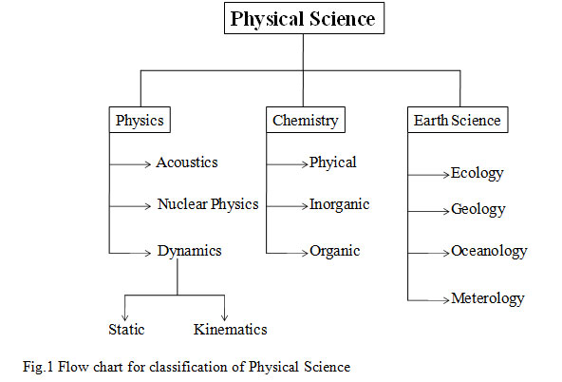

**Father of Chemistry**

If you are asked to identify the Father of Chemistry for homework assignment, your best answer probably is [Antoine Lavoisier](http://chemistry.about.com/b/2011/08/25/this-day-in-science-history-august-26-antoine-lavoisier.htm). Lavoisier wrote the book ‘*Elements of Chemistry* (1787)’. He compiled the first complete (at that time) list of elements, discovered and named oxygen and hydrogen, helped develop the metric system, helped revise and standardize chemical nomenclature and discovered that matter retains its mass even when it changes forms.

Another popular choice for the title of Father of Chemistry is Jabir ibn Hayyan, a Persian alchemist living around 800 AD who applied scientific principles to his studies. Other people sometimes known as the Father of Modern Chemistry are [Robert Boyle](http://chemistry.about.com/od/famouschemists/p/boylebio.htm), [Jöns Berzelius](http://chemistry.about.com/od/famouschemists/p/jjberzeliusbio.htm) and [John Dalton](http://chemistry.about.com/b/2011/07/26/this-day-in-science-history-july-27-john-dalton.htm).

**Other "Father of Chemistry" Scientists**

Other scientists are called the Father of Chemistry or are noted in specific fields of chemistry:

|  |  |  |
| --- | --- | --- |
| **Subject** | **Name** | **Reason** |
| Father of Early Chemistry Father of Chemistry | [Jabir ibn Hayyan (Geber)](http://chemistry.about.com/od/alchemy/ig/Alchemy-Pictures-and-Images/Jabir-ibn-Hayyan.htm) | Introduced the experimental method to alchemy, circa 815. |
| Father of Modern Chemistry | Antoine Lavoisier | Book: Elements of Chemistry (1787) |
| Father of Modern Chemistry | Robert Boyle | Book: The ScepticalChymist (1661) |
| Father of Modern Chemistry | Jöns Berzelius | developed chemical nomenclature in the 1800s |
| Father of Modern Chemistry | John Dalton | revived atomic theory |
| Father of Early Atomic Theory | Democritus | founded atomism in cosmology |
| Father of Atomic Theory Father of Modern Atomic Theory | John Dalton | first to propose the atom as a building block of matter |
| Father of Modern Atomic Theory | Father Roger Boscovich | described what came to be known as modern atomic theory, about a century before others formalized the theory |
| Father of Nuclear Chemistry | Otto Hahn | Book: Applied Radiochemistry (1936) first person to split the atom (1938) Nobel Prize in Chemistry for discovering nuclear fission (1944) |
| Father of the Periodic Table | Dmitri Mendeleev | arranged all the known elements in order of increasing atomic weight, according to periodic properties (1869) |
| Father of Physical Chemistry | Hermann von Helmholtz | for his theories on thermodynamics, conservation of energy and electrodynamics |
| Father of Physical Chemistry Founder of Chemical Thermodynamics | Willard Gibbs | published the first unified body of theorems describing thermodynamics |

**Chemistry** is a branch of Physical science which deals with the study of the composition of matter and the chemical changes involved in it. In other words, chemistry is the science of matter and its transformation. Chemistry is an important branch of science and is often intertwined with branches of science like Physics, Biology, and Geology etc. Different manifestations of chemistry include drugs, polymers, dyes, soaps, detergents, acids, bases, salts, metals, alloys etc. In simple words, scope of chemistry is everywhere and every time.

**Importance of Chemistry**

Chemistry plays an essential role in daily life. It has helped us to meet all our requirements for a better living. Without the knowledge of Chemistry, our life would have been very dull and dreary. *Chemistry is the branch of physical science which studies the composition, properties and interaction of matter*. Chemistry plays a central role in science and is often intertwined with other branches of science like physics, biology, geology etc. Chemistry also plays an important role in daily life.

Some important applications of Chemistry are given below:

**Food Industry**

With an increase in population, the need for the overall amount of food has increased manifold. In addition, with a raise in the standard of living, there has been an increase in the quantity, quality and variety of foods.

• Chemistry has helped us achieve these goals. It has provided chemical fertilizers such as urea, calcium superphosphate, sodium nitrate and ammonium sulphate which have increased the yield of fruits, vegetables and other crops.

• It has helped protect crops from insects and harmful bacteria by using certain effective insecticides, fungicides and pesticides.

• the use of preservatives has helped to preserve food products such as jams, butter and squashes for a longer period.

• Chemistry has provided us with tried and tested methods to determine the presence of adulterants, thereby ensuring the supply of high-quality foodstuff.

**Health and Sanitation**

Chemistry plays an important role in meeting the human needs of food, health care products and other materials aimed at improving the quality of life.

• This is exemplified by the large-scale production of a variety of fertilizers and improved pesticides and insecticides. Similarly, life-saving drugs such as **cisplatin and taxol** are effective in cancer therapy and **azidothymidine (AZT)** used for helping AIDS victims have been isolated from plant and animal sources or prepared by synthetic methods.

• *Analgesics* have *reduced pain* of different types. Antibiotics such as Chloromycetin and streptomycin have helped curb infection and cure diseases such as typhoid and tuberculosis.

• *Tranquillizers* have helped to *reduce tension* and bring about calm and peace to patients suffering from mental diseases.

• *Antiseptics* such as Dettol are used *to stop infection* of wounds. *Disinfectants* such as phenol are used *to kill microorganisms* present in drains, toilets and floors.

• A low concentration of chlorine, i.e. 0.2−0.4 parts per million (ppm), is used for the sterilization of water to make it fit for drinking purposes.

• Discovery of *anesthetics (used to make the patients unconscious)* has made *surgical operations* more successful.

• the use of insecticides such as dichlorodiphenyltrichloroethane (DDT) and gammexane has reduced the hazards of diseases caused by rats, mosquitoes and flies.

• New and more effective medicines are being discovered from time to time which are replacing the older less effective medicines. For example, quinine has been replaced by more effective anti-malarial such as chloroquine, camoquin and primaquine.

• Synthetic vitamins and tonics have contributed significantly towards better health.

• In fact, the use of more effective medicines and vitamins and better sanitary conditions have helped increase average lifespan.

**Safer Alternatives for Environment Hazards**

Refrigerants such as chlorofluorocarbons (CFCs) which are responsible for ozone depletion in the stratosphere have been successfully replaced by environment-friendly chemicals. However, many large environmental problems continue to be matters of grave concern to chemists. One such problem is the management of greenhouse gases such as methane and carbon dioxide.

**Applications in Industry**

• Chemistry has played an important and useful role towards the development and growth of several industries. Examples: Glass, cement, paper, textiles, leather, dye, paints, pigments, petroleum, sugar, plastics and pharmaceuticals.

• It has also helped in the greater production of sulphuric acid, nitric acid, ammonia and hydrogenated oils by providing suitable catalysts.

• Similarly, it has helped in the synthesis of new materials with specific magnetic, electrical and optical properties which are used in the production of superconducting ceramics, conducting polymers and optical fibers.

• Chemical industries manufacturing fertilizers, alkalis, acids, salts, dyes, polymers, drugs, soaps, detergents, metals, alloys and other inorganic and organic chemicals, including new materials, largely contribute to the national economy.

• Understanding of biochemical processes, use of enzymes for large-scale production of chemicals and synthesis of new exotic materials are some intellectual challenges for the future generation of chemists.

**Nuclear Energy**

• In view of the decreasing coal and petroleum resources, the world will soon be facing an energy crisis. Chemistry has come to the rescue by providing an alternative source of energy which is nuclear energy.

• Nuclear energy can also be used for digging tunnels, blasting mountains and in mining.

**Areas of Chemistry**

The study of modern chemistry has many branches, but can generally be broken down into five main disciplines, or areas of study:

* **Physical chemistry:** Physical chemistry is the study of macroscopic properties, atomic properties, and phenomena in chemical systems. A physical chemist may study such things as the rates of chemical reactions, the energy transfers that occur in reactions, or the physical structure of materials at the molecular level.
* **Organic chemistry:** Organic chemistry is the study of chemicals containing carbon. Carbon is one of the most abundant elements on Earth and is capable of forming a tremendously vast number of chemicals (over twenty million so far). Most of the chemicals found in all living organisms are based on carbon.
* **Inorganic chemistry:** Inorganic chemistry is the study of chemicals that do not, in general, contain carbon. Inorganic chemicals are commonly found in rocks and minerals. One current important area of inorganic chemistry deals with the design and properties of materials involved in energy and information technology.
* **Analytical chemistry:**Analytical chemistry is the study of the composition of matter. It focuses on separating, identifying, and quantifying chemicals in samples of matter. An analytical chemist may use complex instruments to analyze an unknown material in order to determine its various components.
* **Biochemistry:** Biochemistry is the study of chemical processes that occur in living things. Research may cover basic cellular processes up to understanding disease states so better treatments can be developed.

**……………………**